Nebraska RDHRE Bamlanivimab Implementation Plan

Concept of Operations: Nebraska‘s Region-7 Disaster Health Response Ecosystem program will coordinate a pilot project to administer Lilly’s EUA monoclonal antibody (mAb) product, bamlanivimab, to highest risk COVID-19 outpatients in long-term care (LTCF) and other congregate living facilities. The goal of this pilot is to demonstrate the efficacy of this targeted strategy to reduce hospitalization, morbidity and mortality, and ultimately strain on the healthcare system during intensive community COVID-19 epidemics. Currently, LTCF in NE are testing residents twice weekly per CMS guidelines. These results will be used to trigger response teams centered at local hospitals with relationships with LTCF to identify COVID-+ residents meeting EUA eligibility criteria and support infusion services – with hospital based mobile teams when LTCF do not have staffing capacity/capability. This pilot program will be implemented in multiple regions of the state, working with healthcare coalitions (HCC) or local healthcare delivery networks, and it will be coordinated by the Nebraska Medicine/University of Nebraska Medicine, the RDHRE, and the state’s COVID Medical Emergency Operations Center.

Distribution strategy: Nebraska Medicine and Nebraska Antimicrobial Stewardship Assessment and Prevention Program (ASAP) network will serve as the central distribution facilities.
- Requests made through a survey on the ASAP website w/ Primary Care Provider’s order. Orders will be shipped or delivered via Nebraska State Patrol or medical courier to a supporting facility.
- Receiving/supporting facilities will administer bamlanivimab according to EUA guidelines.
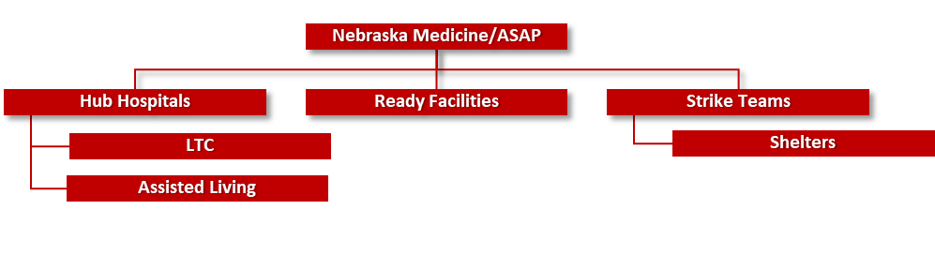
Phase 1 – Pilot Community
Great Plains Regional Medical Center (GPRMC) Hub Distribution Scheme
  - GPRMC North Platte, and critical access hospitals in:
    - McCook, NE (serves LTCF in NW Kansas also)
    - Lexington, NE
    - Ogallala, NE
Phase 2A – Expand Distribution to Ready Facilities
- LTC and other facilities that have qualified staff and equipment to provide the infusion per the EUA guidelines or can coordinate support organically.
Phase 2B - Expand to other Hub Hospitals
Request support from healthcare coalitions and primary medical systems to assist long term care and assisted living facilities with bamlanivimab infusion.
  - Required support would include trained staff and medical supplies
  - Pharmaceutical support for dilution
Phase 3 – Identify Outliers and Expand Support
Deployable infusion teams would be assembled administer medication and monitor patients in outlier facilities (e.g., shelters)

